https://www.youtube.com/watch?v=tGqhlV-kaFU

Microsoft SQL Server Installation:

Step-1:
Type Microsoft sql server in any browser currently we have sql server 2022 edition
https://www.microsoft.com/en-in/sql-server/sql-server-downloads

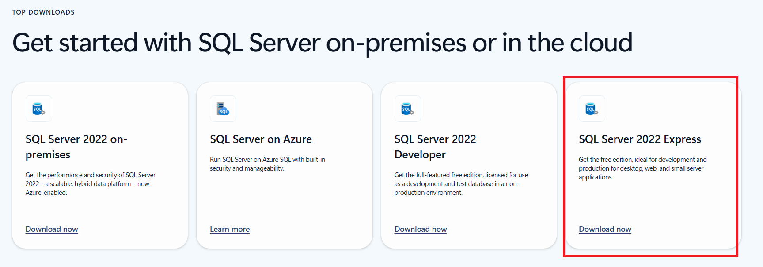

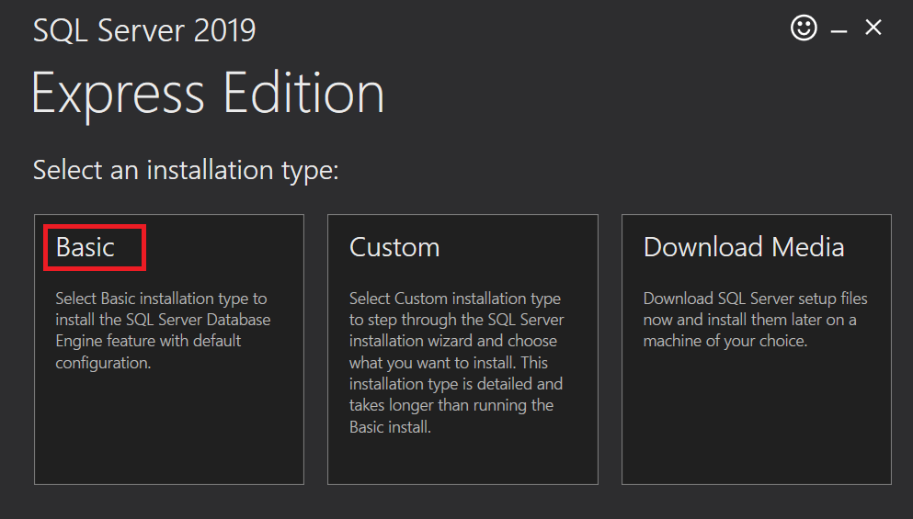

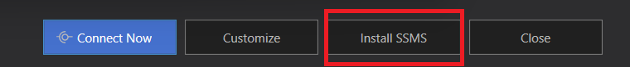

SSMS=Sequel server management studio

https://learn.microsoft.com/en-us/sql/ssms/download-sql-server-management-studio-ssms?view=sql-server-ver16#download-ssms

